APCD Full Cohort

Kristen Campbell

December 8, 2020

**Table 1a: Patient and index admission characteristics**

|  |  |  |  |  |
| --- | --- | --- | --- | --- |
| Characteristic | All (n=381) | Phenotype1 (n=300) | Phenotype 2 (n=62) | Phenotype 3 (n=19) |
| **Age (months)** | 39.6 (11, 148.2) | 36.3 (10.1, 143.7) | 36.3 (10.9, 148) | 98.6 (42.8, 158.4) |
| **Gender** |  |  |  |  |
| Male | 229 (60%) | 183 (61%) | 36 (58%) | 10 (53%) |
| Female | 152 (40%) | 117 (39%) | 26 (42%) | 9 (47%) |
| **CCC - gold standard** |  |  |  |  |
| None | 178 (47%) | 161 (54%) | 16 (26%) | 1 (5%) |
| CCC | 147 (39%) | 86 (29%) | 43 (69%) | 18 (95%) |
| NC-CC | 56 (15%) | 53 (18%) | 3 (5%) | 0 (0%) |
| **PRISM III Score** | 5 (2, 12) | 5 (2, 11) | 6 (2, 14.8) | 7 (0.5, 12) |
| **Race/Ethnicity** |  |  |  |  |
| White | 211 (55%) | 170 (57%) | 31 (50%) | 10 (53%) |
| Hispanic or Latino | 96 (25%) | 69 (23%) | 19 (31%) | 8 (42%) |
| Black or African American | 29 (8%) | 25 (8%) | 3 (5%) | 1 (5%) |
| Other/unspecified | 45 (12%) | 36 (12%) | 9 (15%) | 0 (0%) |
| **ICU Year** |  |  |  |  |
| 16 | 86 (23%) | 75 (25%) | 10 (16%) | 1 (5%) |
| 15 | 92 (24%) | 74 (25%) | 13 (21%) | 5 (26%) |
| 14 | 115 (30%) | 86 (29%) | 21 (34%) | 8 (42%) |
| 13 | 88 (23%) | 65 (22%) | 18 (29%) | 5 (26%) |
| **PIM2 Score - risk** | 3.1 (0.8, 5.4) | 3.1 (0.8, 4.8) | 3.6 (1, 14.3) | 10.2 (3.3, 16.2) |
| **Patient Origin** |  |  |  |  |
| Emergency Dept/Clinic direct admit | 243 (64%) | 193 (64%) | 38 (61%) | 12 (63%) |
| OR/PACU | 61 (16%) | 47 (16%) | 11 (18%) | 3 (16%) |
| General Care Floor | 49 (13%) | 34 (11%) | 11 (18%) | 4 (21%) |
| Outside Hospital Transfer | 28 (7%) | 26 (9%) | 2 (3%) | 0 (0%) |
| **ECMO** |  |  |  |  |
| 0 | 373 (98%) | 293 (98%) | 61 (98%) | 19 (100%) |
| 1 | 8 (2%) | 7 (2%) | 1 (2%) | 0 (0%) |
| **CRRT** |  |  |  |  |
| 0 | 380 (100%) | 299 (100%) | 62 (100%) | 19 (100%) |
| 1 | 1 (0%) | 1 (0%) | 0 (0%) | 0 (0%) |
| **HFOV** |  |  |  |  |
| 0 | 372 (98%) | 292 (97%) | 61 (98%) | 19 (100%) |
| 1 | 9 (2%) | 8 (3%) | 1 (2%) | 0 (0%) |
| **CPR - in hospital** |  |  |  |  |
| 0 | 366 (96%) | 291 (97%) | 57 (92%) | 18 (95%) |
| 1 | 15 (4%) | 9 (3%) | 5 (8%) | 1 (5%) |
| **tracheostomy** |  |  |  |  |
| 0 | 348 (91%) | 279 (93%) | 52 (84%) | 17 (89%) |
| 1 | 33 (9%) | 21 (7%) | 10 (16%) | 2 (11%) |
| **Complicated ICU Stay - CRRT, ECMO, CPR, HFOV, or Tracheostomy** |  |  |  |  |
| 0 | 315 (83%) | 254 (85%) | 45 (73%) | 16 (84%) |
| 1 | 66 (17%) | 46 (15%) | 17 (27%) | 3 (16%) |
| **Severity of ARDS** |  |  |  |  |
| No/Mild | 140 (37%) | 108 (36%) | 24 (39%) | 8 (42%) |
| Moderate | 106 (28%) | 85 (28%) | 15 (24%) | 6 (32%) |
| Severe | 135 (35%) | 107 (36%) | 23 (37%) | 5 (26%) |
| **Days of ARDS (any)** | 4 (2, 7) | 4 (2, 7) | 6 (3, 10) | 3 (2, 7) |
| **Total Moderate/Severe ARDS Days** | 2 (0, 4) | 1.5 (0, 4) | 2 (0, 5) | 1 (0, 2) |
| **Duration of Mechanical Ventilation** | 6.7 (4.6, 9.9) | 6.5 (4.5, 9.2) | 7.8 (5.7, 11.8) | 6.2 (4.1, 10.9) |
| **Days in PICU** | 10.4 (7.1, 15.2) | 10.1 (6.9, 14.2) | 12.6 (8.5, 19) | 10 (7.4, 16.7) |
| **Days in Hospital** | 21.6 (12.9, 43.4) | 19.5 (12.4, 39.8) | 35.5 (17.8, 75.6) | 20.5 (13, 34.9) |
| **Months to Death** |  |  |  | 2.0 (1.1, 8.4), range: 0.08-11.7 |

ARDS designations: 13/241 subjects designated as having mod/sev ARDS were demonstrated not to have ARDS upon chart review (time duration and ARDs risk factor).

**Table 1b: DME types within 1 month of hospital discharge**

|  |  |  |  |  |
| --- | --- | --- | --- | --- |
| **DME** | **All**  **(n=381)** | **Phenotype1 (n=300)** | **Phenotype2 (n=62)** | **Phenotype3 (n=19)** |
| Any DME | 167 (44%) | 94 (31%) | 59 (95%) | 14 (74%) |
| DME number, if any | 4 (2, 8) | 3 (1, 5) | 8 (4, 11) | 4.5 (2.25, 5.75) |
| communication, if any | 2.5 (2, 3.25) | 4 (4, 4) | 2 (2, 2.5) | NA (NA, NA) |
| communication | 4 (1%) | 1 (0%) | 3 (5%) | 0 (0%) |
| dialysis, if any | NA (NA, NA) | NA (NA, NA) | NA (NA, NA) | NA (NA, NA) |
| dialysis | 0 (0%) | 0 (0%) | 0 (0%) | 0 (0%) |
| feeding, if any | 3 (2, 6) | 2.5 (2, 4) | 5 (3, 7.5) | 2 (2, 3) |
| feeding | 116 (30%) | 56 (19%) | 51 (82%) | 9 (47%) |
| foley, if any | 1 (1, 1) | 1 (1, 1) | 1 (1, 1.5) | NA (NA, NA) |
| foley | 6 (2%) | 3 (1%) | 3 (5%) | 0 (0%) |
| hear_comm, if any | 6.5 (1, 26.25) | 9 (2.5, 14.5) | 5.5 (1, 29.75) | 4 (4, 4) |
| hear_comm | 5 (1%) | 1 (0%) | 3 (5%) | 1 (5%) |
| hearing, if any | 1 (1, 1) | NA (NA, NA) | NA (NA, NA) | 1 (1, 1) |
| hearing | 1 (0%) | 0 (0%) | 0 (0%) | 1 (5%) |
| infusion, if any | 1 (1, 1) | 1 (1, 1) | 1 (1, 1) | 1 (1, 1) |
| infusion | 5 (1%) | 3 (1%) | 1 (2%) | 1 (5%) |
| mobility, if any | 1 (1, 1) | 1 (1, 2) | 1 (1, 1) | NA (NA, NA) |
| mobility | 15 (4%) | 7 (2%) | 8 (13%) | 0 (0%) |
| respiratory, if any | 2 (1, 3) | 1 (1, 3) | 3 (1, 3.5) | 3 (2, 3) |
| respiratory | 94 (25%) | 41 (14%) | 43 (69%) | 10 (53%) |
| therapy, if any | 2 (1, 2) | 2 (1, 4) | 1 (1, 2) | 2 (1.75, 2.25) |
| therapy | 39 (10%) | 21 (7%) | 14 (23%) | 4 (21%) |
| tracheostomy, if any | 2 (2, 3) | 3 (1, 3) | 2 (2, 3) | 1 (1, 1) |
| tracheostomy | 13 (3%) | 5 (2%) | 7 (11%) | 1 (5%) |

**Table 1c: Primary Diagnoses**

|  |  |  |  |
| --- | --- | --- | --- |
| **Primary Dx** | **Phenotype1 (n=300)** | **Phenotype2 (n=62)** | **Phenotype3 (n=19)** |
| Respiratory | 121 (40%) | 25 (40%) | 9 (47%) |
| Injury | 78 (26%) | 10 (16%) | 1 (5%) |
| Neurologic | 30 (10%) | 8 (13%) | 3 (16%) |
| Infectious | 20 (7%) | 6 (10%) | 3 (16%) |
| Gastrointestinal | 12 (4%) | 8 (13%) | 2 (11%) |
| Dermatologic | 7 (2%) | 0 (0%) | 0 (0%) |
| Cardiovascular | 6 (2%) | 2 (3%) | 0 (0%) |
| Oncologic | 6 (2%) | 1 (2%) | 0 (0%) |
| Poisoning/Adverse Effects | 6 (2%) | 1 (2%) | 0 (0%) |
| Genetic | 3 (1%) | 0 (0%) | 0 (0%) |
| Symptoms | 3 (1%) | 0 (0%) | 0 (0%) |
| Endocrinologic | 2 (1%) | 0 (0%) | 0 (0%) |
| Orthopedic | 2 (1%) | 0 (0%) | 0 (0%) |
| Transplant | 2 (1%) | 1 (2%) | 0 (0%) |
| Metabolic | 1 (0%) | 0 (0%) | 0 (0%) |
| Rheumatologic | 1 (0%) | 0 (0%) | 0 (0%) |
| Hematologic | 0 (0%) | 0 (0%) | 0 (0%) |
| Immunologic | 0 (0%) | 0 (0%) | 0 (0%) |
| Renal/Genitourinary | 0 (0%) | 0 (0%) | 1 (5%) |

**Table 2a: Univariate logistic regression for phenotype membership**

Each predictor was included a two univariate logistic regression models. The first had phenotype 2 as the outcome, in reference to phenotype 1. Patients in phenotype 3 were removed from these analyses (column 2). The second had phenotype 3 as the outcome, in reference to phenotype 1 (patients in phenotype 2 were removed).

|  |  |  |
| --- | --- | --- |
| **Parameter** | **PHENOTYPE 2 (n=62), vs. Phen1** | **PHENOTYPE 3 (n=19), vs. Phen1** |
|  | **OR (95% CI)** | **OR (95% CI)** |
| Age at Mechanical Ventilation | 1.01 (0.97, 1.05); p=0.5599 | 1.06 (0.99, 1.13); p=0.0836 |
| Female | 1.13 (0.64, 1.96); p=0.667 | 1.41 (0.54, 3.59); p=0.4711 |
| Race/Ethnicity (reference=White) | p=0.4476 | p=0.0747 |
| Hispanic or Latino | 1.51 (0.79, 2.83) | 1.97 (0.72, 5.21) |
| Other | 1.08 (0.5, 2.19) | 0.28 (0.02, 1.5) |
| PRISM III Score | 1.03 (0.99, 1.07); p=0.097 | 1.02 (0.95, 1.09); p=0.5658 |
| PIM2 Score - risk | 1.03 (1, 1.05); p=0.0344 | 1.05 (1, 1.09); p=0.0287 |
| CCC (vs. none/NC-CC) | 5.63 (3.15, 10.41); p<0.001 | 44.79 (9.04, 812.06); p<0.001 |
| Patient Origin (ref=ED/clinic direct) | p=0.8899 | p=0.9931 |
| General Care Floor/other hospital | 1.1 (0.53, 2.16) | 1.07 (0.29, 3.21) |
| OR/PACU | 1.19 (0.54, 2.43) | 1.03 (0.23, 3.39) |
| Pre-Hospital cardiac arrest or massage | 1.87 (0.79, 4.1); p=0.1337 | 0.61 (0.03, 3.16); p=0.6384 |
| Severity of ARDS (ref=no/mild) | p=0.7942 | p=0.6964 |
| Moderate | 0.79 (0.39, 1.59) | 0.95 (0.3, 2.84) |
| Severe | 0.97 (0.51, 1.82) | 0.63 (0.19, 1.95) |
| Days of ARDS | 1.03 (1, 1.06); p=0.0759 | 0.97 (0.84, 1.03); p=0.5854 |
| Total Moderate/Severe ARDS Days | 1.03 (0.98, 1.09); p=0.2208 | 0.87 (0.68, 1.02); p=0.1669 |
| Year of index ICU (ref=2016) | p=0.2849 | p=0.1470 |
| 15 | 1.32 (0.55, 3.27) | 5.07 (0.79, 98.33) |
| 14 | 1.83 (0.83, 4.29) | 6.98 (1.24, 130.93) |
| 13 | 2.08 (0.91, 4.98) | 5.77 (0.9, 112.05) |
| Duration of Mechanical Ventilation (days) | 1.02 (0.99, 1.05); p=0.1084 | 0.99 (0.9, 1.04); p=0.8028 |
| Days in Hospital | 1.01 (1.01, 1.02); p<0.001 | 0.99 (0.97, 1.01); p=0.4106 |
| PICU LOS - Days | 1.03 (1.01, 1.05); p=0.0083 | 1.01 (0.95, 1.04); p=0.7692 |
| ECMO | 0.69 (0.04, 3.95); p=0.7269 | NA |
| HFOV | 0.6 (0.03, 3.35); p=0.6312 | NA |
| CPR - in hospital | 2.84 (0.85, 8.53); p=0.0704 | 1.8 (0.09, 10.37); p=0.5882 |
| Tracheostomy | 2.55 (1.1, 5.62); p=0.0231 | 1.56 (0.24, 5.97); p=0.5674 |
| Complicated ICU Stay | 2.09 (1.08, 3.91); p=0.0244 | 1.04 (0.23, 3.26); p=0.9574 |
| Primary Dx: Respiratory | 1 (0.57, 1.74); p=0.9987 | 1.33 (0.51, 3.4); p=0.5462 |
| Primary Dx: Injury | 0.55 (0.25, 1.09); p=0.1029 | 0.16 (0.01, 0.79); p=0.075 |
| Primary Dx: Neurologic | 1.33 (0.55, 2.94); p=0.4984 | 1.69 (0.38, 5.44); p=0.4264 |
| Primary Dx: Infectious | 1.5 (0.53, 3.7); p=0.406 | 2.62 (0.58, 8.73); p=0.15 |
| Primary Dx: GI | 3.56 (1.34, 9.01); p=0.0082 | 2.82 (0.42, 11.49); p=0.1964 |
| Primary Dx: Cardio | 1.63 (0.24, 7.29); p=0.5538 | NA |
| Primary Dx: Poisoning/Adverse Effects | 0.8 (0.04, 4.82); p=0.8406 | NA |
| Primary Dx: Oncologic | 0.8 (0.04, 4.82); p=0.8406 | NA |

**Table 2b: Phenotype 2 – multivariable logistic regression**

|  |  |  |
| --- | --- | --- |
| Parameter | OR (95% CI) – Phenotype 2 (versus phenotype 1) | P Value |
| CCC (ref=none/NC-CC) | 5.05 (2.77, 9.49) | <0.001 |
| Primary Dx: GI | 2.49 (0.89, 6.69) | 0.0738 |
| PIM2 Score - risk | 1.03 (1, 1.06) | 0.0494 |
| PICU LOS - Days | 1.02 (1, 1.04) | 0.104 |

After adjusting for whether the patient had a primary GI diagnosis, the PIM2 risk score, and PICU length of stay, having a CCC increased the odds of membership in Phenotype 2 compared to phenotype 1.

**Table 2c: Phenotype 3 - multivariable logistic regression**

|  |  |  |
| --- | --- | --- |
| Parameter | OR (95% CI) – Phenotype 3 (versus phenotype 1) | P Value |
| CCC (ref=none/NC-CC) | 43.04 (8.63, 782.14) | <0.001 |
| PIM2 Score - risk | 1.04 (0.99, 1.1) | 0.0969 |

**Figure 1:**

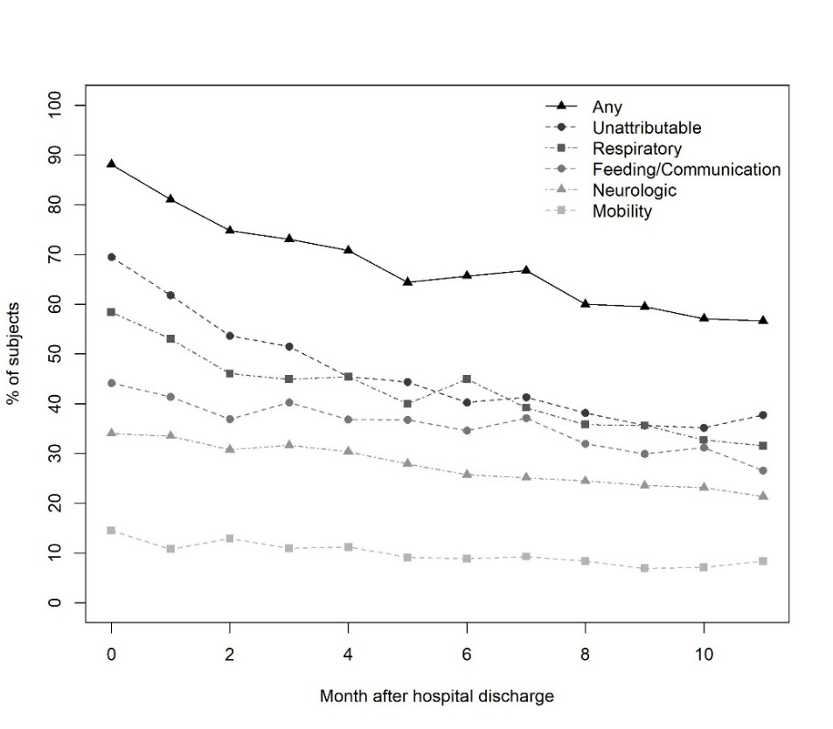

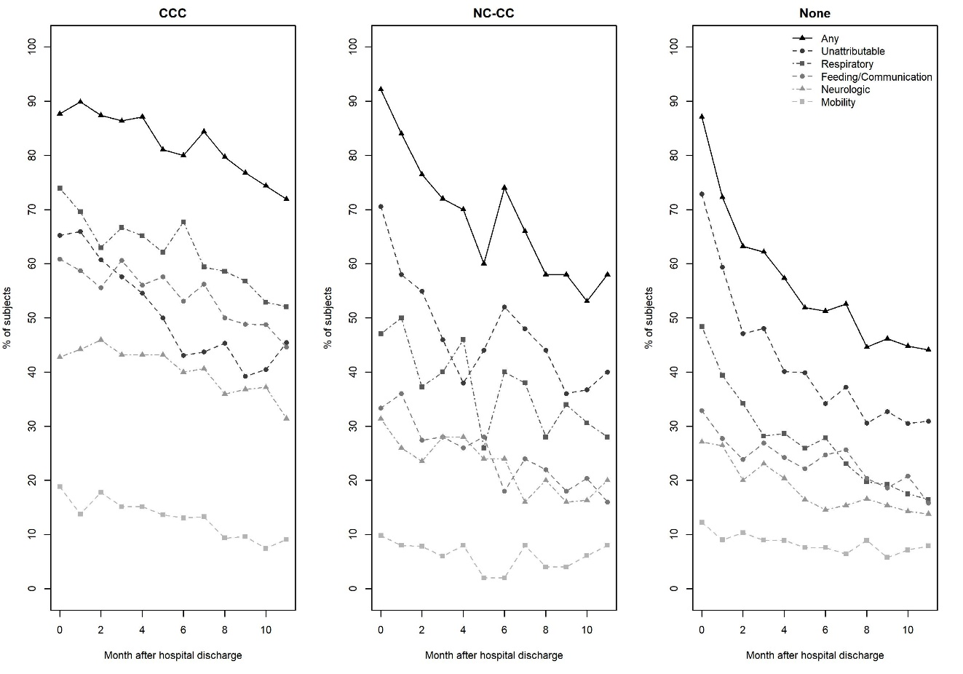

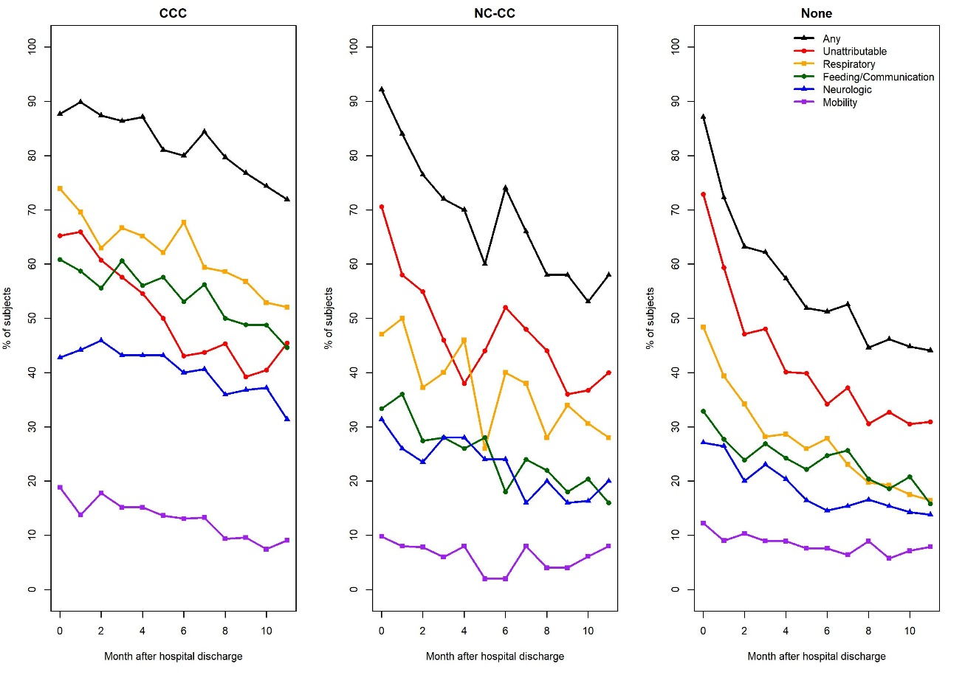

**Figure 2:**

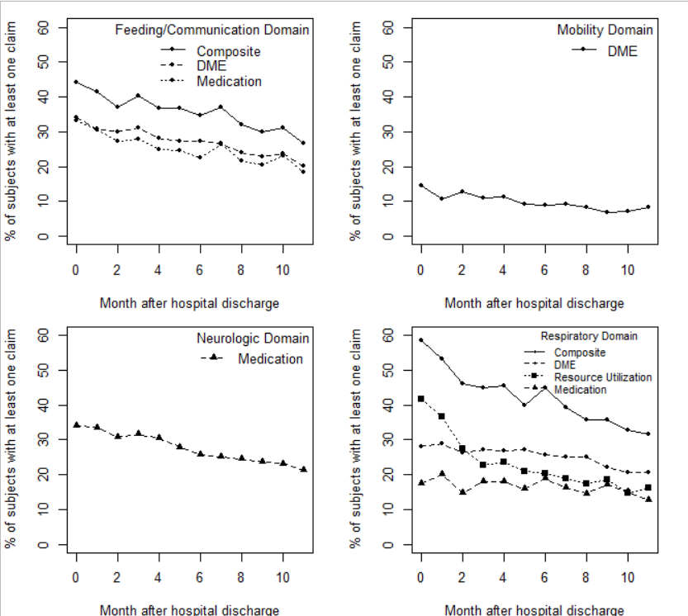

**Figure 3:**

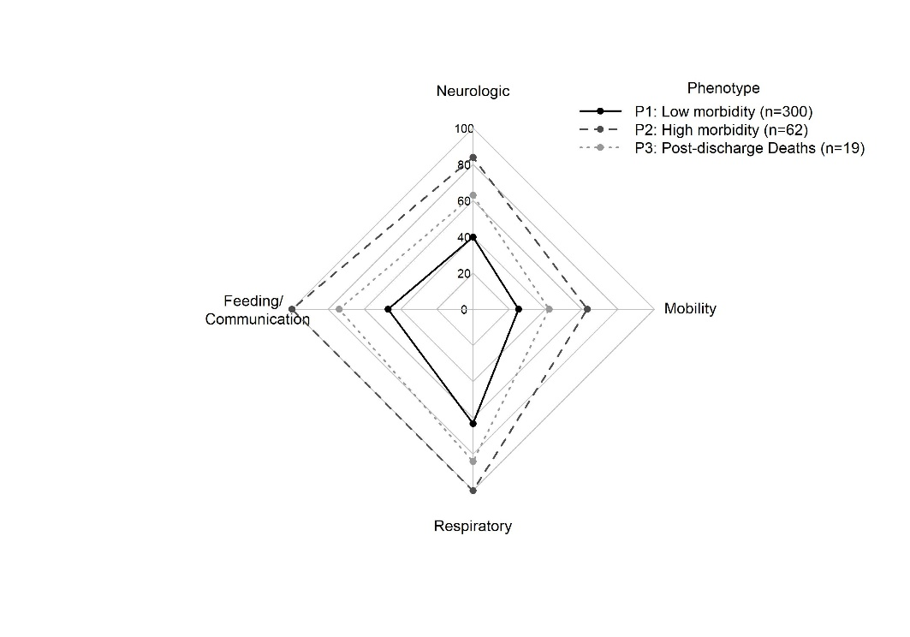

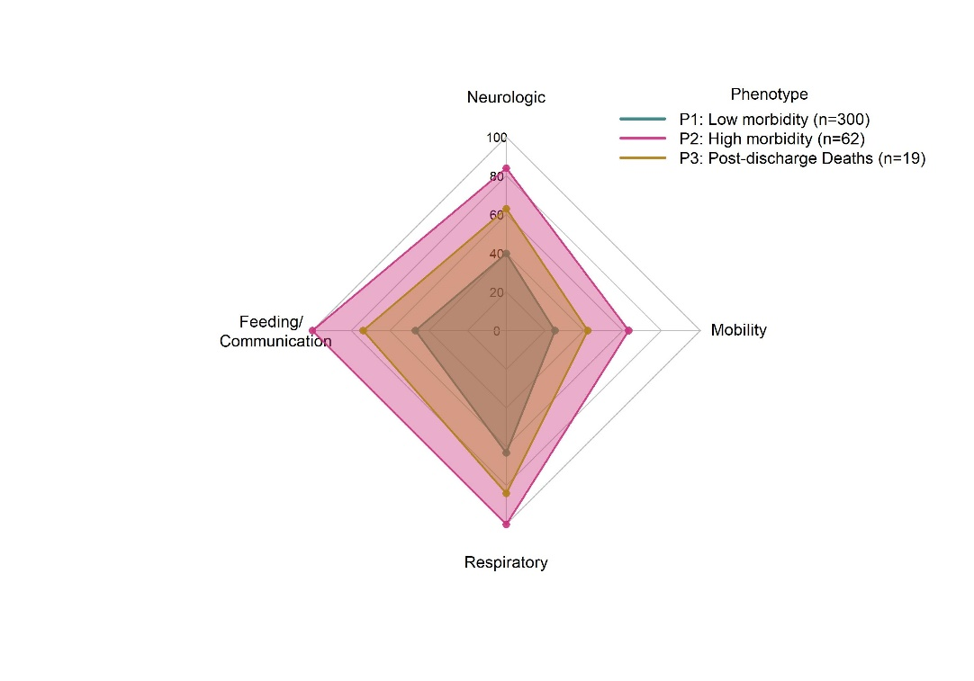

**Table 3: Claim trends**

|  |  |  |  |  |
| --- | --- | --- | --- | --- |
| **Claim Trend** | **All (n=381)** | **Phenotype1  (n=300)** | **Phenotype2  (n=62)** | **Phenotype3 (n=19)** |
| Low | 124 (39%) | 124 (49%) | 0 (0%) | 0 (NaN%) |
| Decreasing | 111 (35%) | 81 (32%) | 30 (49%) | 0 (NaN%) |
| High | 49 (16%) | 23 (9%) | 26 (43%) | 0 (NaN%) |
| Increasing | 32 (10%) | 27 (11%) | 5 (8%) | 0 (NaN%) |
| Insufficient eligibility | 65 (17%) | 45 (15%) | 1 (2%) | 19 (100%) |

**Figure 4: Claim Trends**

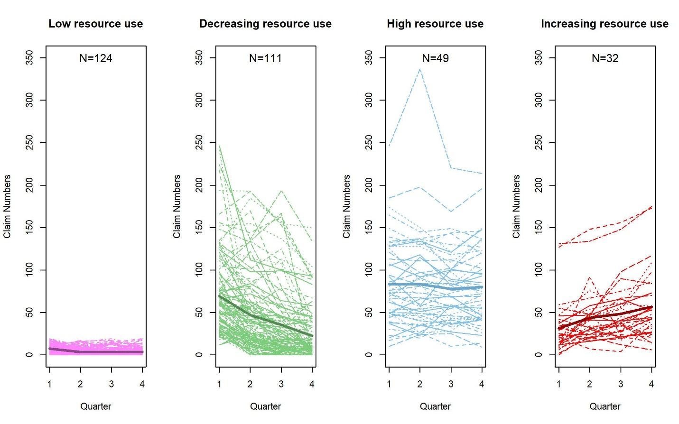

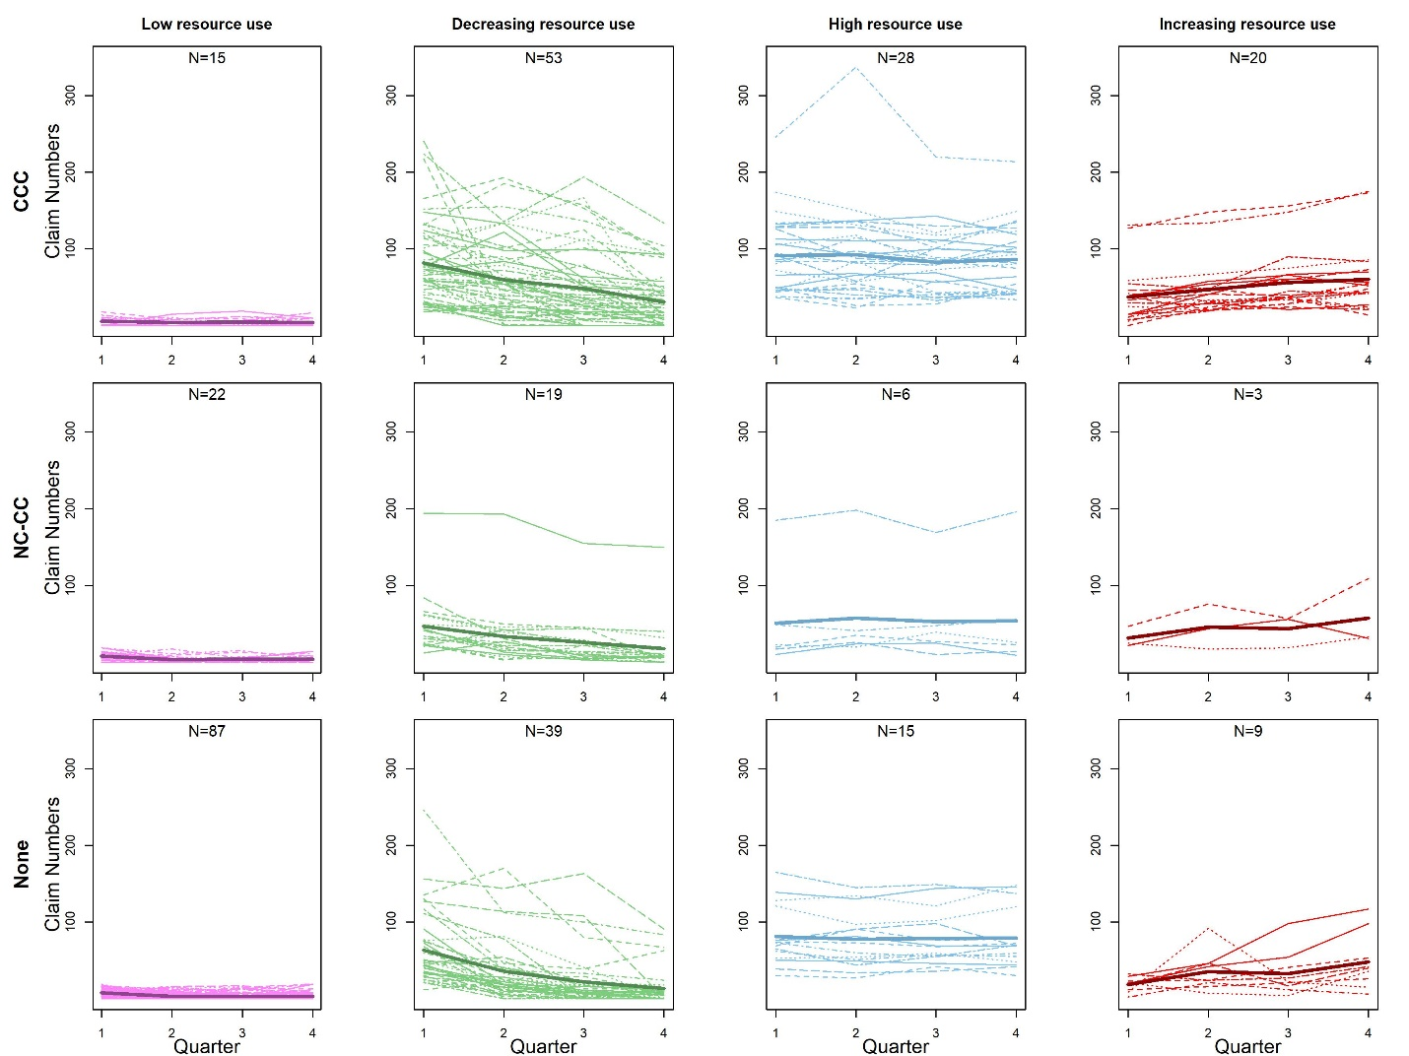

**Figure 5: Radar plots by claim trends**

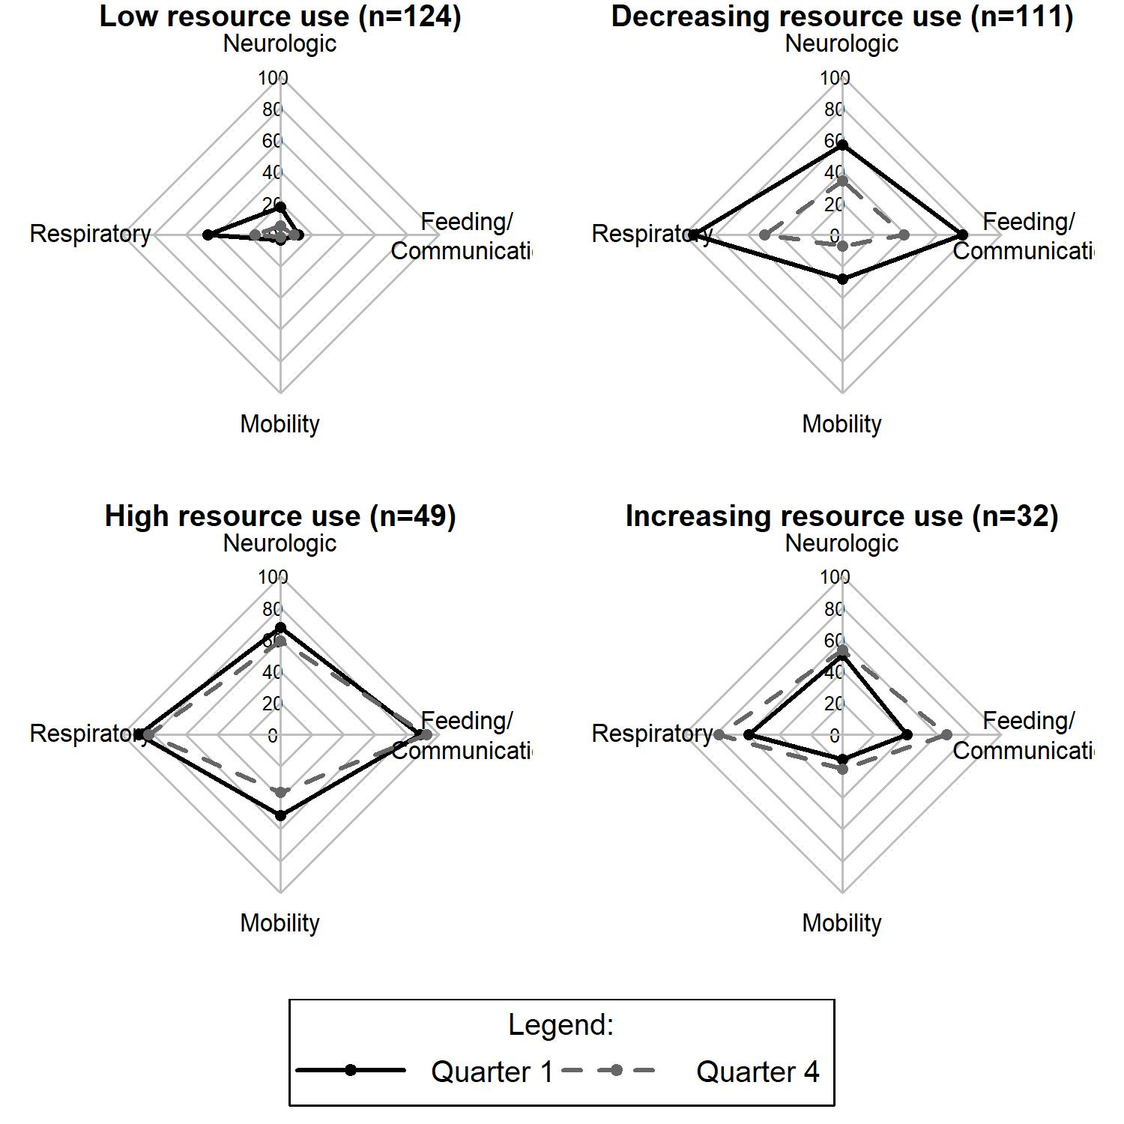

**Table 4: Radar plot percentages**

|  |  |  |  |  |
| --- | --- | --- | --- | --- |
| Morbidity Domain | low (n=124) | dec (n=111) | equal (n=49) | inc (n=32) |
| **fs_q1** | 14 (11%) | 84 (76%) | 43 (88%) | 13 (41%) |
| **fs_q4** | 10 (8%) | 43 (39%) | 45 (92%) | 21 (66%) |
| **mob_q1** | 4 (3%) | 31 (28%) | 25 (51%) | 5 (16%) |
| **mob_q4** | 2 (2%) | 8 (7%) | 18 (37%) | 7 (22%) |
| **neuro_q1** | 22 (18%) | 63 (57%) | 33 (67%) | 16 (50%) |
| **neuro_q4** | 7 (6%) | 38 (34%) | 29 (59%) | 17 (53%) |
| **resp_q1** | 57 (46%) | 105 (95%) | 44 (90%) | 19 (59%) |
| **resp_q4** | 20 (16%) | 55 (50%) | 41 (84%) | 25 (78%) |

**Table 5a: Univariate logistic regression models for resource use category**

Each predictor was included a two univariate logistic regression models. The first had decreasing claim trend as the outcome, in reference to low. Patients in the high/increasing group were removed from these analyses (column 2). The second had high/increasing as the outcome, in reference to low (patients in decreasing were removed).

|  |  |  |
| --- | --- | --- |
| Parameter | Decreasing (n=111), vs. Low | High/Increasing (n=81), vs. Low |
| Age | 1 (1, 1.01); p=0.144 | 1 (1, 1.01); p=0.0604 |
| Male | 1.43 (0.85, 2.44); p=0.182 | 0.98 (0.56, 1.73); p=0.9472 |
| Chronic Conditions (ref=none) |  |  |
| CCC | 7.88 (4.05, 16.09); p<0.001 | 11.6 (5.69, 24.89); p<0.001 |
| NC-CC | 1.93 (0.93, 3.97); p=0.0745 | 1.48 (0.58, 3.57); p=0.3896 |
| Race (reference=White) | p=0.7124 | p=0.6346 |
| Hispanic or Latino | 0.86 (0.46, 1.6) | 0.79 (0.4, 1.53) |
| Black or African American | 0.72 (0.27, 1.88) | 0.89 (0.33, 2.34) |
| Other/unspecified | 1.3 (0.6, 2.85) | 0.54 (0.18, 1.43) |
| Year of ICU Stay (ref=2016) | p=0.0892 | p<0.001 |
| 15 | 0.57 (0.27, 1.16) | 7.44 (2.31, 33.5); p=0.0024 |
| 14 | 0.62 (0.31, 1.23) | 8.92 (2.84, 39.63); p<0.001 |
| 13 | 1.33 (0.64, 2.81) | 13.75 (4.16, 63.15); p<0.001 |
| PRISM III Score | 1.06 (1.02, 1.1); p=0.0058 | 1.03 (0.99, 1.08); p=0.1614 |
| PIM2 Score - risk | 1.03 (0.99, 1.06); p=0.1317 | 1.03 (1, 1.07); p=0.057 |
| Patient Origin (ref=ED/clinic direct) | p=0.2871 | p=0.3563 |
| OR/PACU | 1.21 (0.56, 2.62) | 1.49 (0.66, 3.31) |
| General Care Floor | 1.99 (0.89, 4.61) | 1.85 (0.76, 4.58) |
| Outside Hospital Transfer | 0.71 (0.25, 1.86) | 0.71 (0.22, 2.03) |
| ECMO | 0.37 (0.02, 2.91); p=0.388 | 1.02 (0.13, 6.29); p=0.982 |
| CPR in hospital | 1.51 (0.33, 7.8); p=0.5963 | 2.1 (0.45, 10.88); p=0.3415 |
| Tracheostomy | 6.71 (1.75, 44.02); p=0.0147 | 17.43 (4.83, 111.86); p<0.001 |
| Complicated ICU Stay | 2.18 (1.03, 4.79); p=0.0452 | 3.93 (1.87, 8.67); p<0.001 |
| Severity of ARDS (ref=moderate) | p=0.2332 | p=0.4332 |
| No/Mild | 1.34 (0.7, 2.59) | 1.53 (0.76, 3.11) |
| Severe | 1.75 (0.92, 3.35) | 1.49 (0.73, 3.07) |
| Total Moderate/Severe ARDS Days | 1.07 (1, 1.15); p=0.0498 | 0.99 (0.9, 1.08) |
| Duration of Mechanical Ventilation (days) | 1.1 (1.05, 1.17); p<0.001 | 1.11 (1.04, 1.19); p=0.0028 |
| PICU LOS - Days | 1.09 (1.05, 1.15); p<0.001 | 1.1 (1.04, 1.16); p<0.001 |
| Days in Hospital | 1.03 (1.01, 1.04); p<0.001 | 1.03 (1.02, 1.04); p<0.001 |
| Primary Dx: Respiratory | 0.73 (0.43, 1.24); p=0.2486 | 0.86 (0.49, 1.52); p=0.6094 |
| Primary Dx: Injury | 0.53 (0.28, 0.98); p=0.0451 | 0.78 (0.4, 1.47); p=0.4491 |
| Primary Dx: Neurologic | 1.65 (0.7, 3.98); p=0.2539 | 1.98 (0.81, 4.93); p=0.1321 |
| Primary Dx: Infectious | 2.03 (0.78, 5.63); p=0.1536 | 1.34 (0.42, 4.18); p=0.6138 |
| Primary Dx: GI | 1.12 (0.37, 3.39); p=0.8308 | 0.87 (0.22, 2.97); p=0.8263 |
| Primary Dx: Cardio | 4.6 (0.67, 90.69); p=0.1752 | 3.11 (0.29, 67.66); p=0.357 |
| Primary Dx: Poisoning/Adverse Effects | 0.37 (0.02, 2.91); p=0.388 | 0.5 (0.02, 4.02); p=0.5562 |
| Primary Dx: Oncologic | 5.8 (0.92, 112.09); p=0.1111 | NA |

**Table 5b: Multivariable for decreasing resource use (ref=low)**

|  |  |  |
| --- | --- | --- |
| Parameter | OR (95% CI) | P Value |
| Chronic Conditions (ref=none) |  | <0.0001 |
| CCC | 7.86 (3.92, 16.52) | <0.0001 |
| NC-CC | 1.99 (0.93, 4.28) | 0.0756 |
| PRISM III Score | 1.03 (0.99, 1.08) | 0.1273 |
| Duration of Mechanical Ventilation (days) | 1.11 (1.05, 1.18) | 0.0009 |

After adjusting for duration of MV and prism score, having a CCC increased the odds of having decreasing resource use, compared to low resource use. Also, compared to low resource use, having longer duration of MV increased the odds of decreasing resource use, after adjusting for prism score and presence of a CCC.

**Table 5c: Multivariable for high/increasing resource use (ref=low)**

|  |  |  |
| --- | --- | --- |
| Parameter | OR (95% CI) | P Value |
| Chronic Conditions (ref=none) |  | <0.001 |
| CCC | 12.66 (5.71, 30.13) | <0.001 |
| NC-CC | 1.66 (0.62, 4.29) | 0.3022 |
| PIM2 Score - risk | 1.03 (0.99, 1.07) | 0.1566 |
| Year of ICU Stay (ref=2016) |  | 0.002 |
| 15 | 10.45 (2.66, 56.41) | 0.0021 |
| 14 | 8.45 (2.18, 44.64) | 0.0047 |
| 13 | 10.29 (2.55, 55.74) | 0.0025 |
| Duration of Mechanical Ventilation (days) | 1.14 (1.06, 1.24) | 0.0011 |

**Supplemental Table 1: matched vs. unmatched index admission characteristics:**

|  |  |  |  |  |
| --- | --- | --- | --- | --- |
| Characteristic | All (n=633) | Matched (n=381) | Unmatched (n=252) | P Value |
| Age (months) | 39.6 (10.9, 139.1) | 39.6 (11, 148.2) | 38.9 (10.9, 129.8) | 0.9938 |
| Gender |  |  |  | 0.5099 |
| Female | 260 (41%) | 152 (40%) | 108 (43%) |  |
| Male | 373 (59%) | 229 (60%) | 144 (57%) |  |
| CCC |  |  |  | 0.001 |
| CCC | 147 (39%) | 147 (39%) | 99 (30%) |  |
| NC-CC | 56 (15%) | 56 (15%) | 14 (6%) |  |
| None | 178 (47%) | 178 (47%) | 139 (55%) |  |
| PRISM III Score | 5 (2, 12) | 5 (2, 12) | 6 (3, 12) | 0.6432 |
| Race/Ethnictiy |  |  |  | 0.076 |
| White | 340 (54%) | 211 (55%) | 129 (51%) |  |
| Hispanic or Latino | 167 (26%) | 96 (25%) | 71 (28%) |  |
| Black or African American | 39 (6%) | 29 (8%) | 10 (4%) |  |
| Other/unspecified | 87 (14%) | 45 (12%) | 42 (17%) |  |
| Year of Index ICU Stay |  |  |  | 0.0301 |
| 16 | 152 (24%) | 86 (23%) | 66 (26%) |  |
| 15 | 167 (26%) | 92 (24%) | 75 (30%) |  |
| 14 | 165 (26%) | 115 (30%) | 50 (20%) |  |
| 13 | 149 (24%) | 88 (23%) | 61 (24%) |  |
| PIM2 Score - risk | 3.1 (0.8, 5) | 3.1 (0.8, 5.4) | 3 (0.8, 4.5) | 0.1373 |
| Patient Origin - categorized |  |  |  | 0.081 |
| Emergency Dept/Clinic direct admit | 401 (63%) | 243 (64%) | 158 (63%) |  |
| OR/PACU | 89 (14%) | 61 (16%) | 28 (11%) |  |
| General Care Floor | 84 (13%) | 49 (13%) | 35 (14%) |  |
| Outside Hospital Transfer | 59 (9%) | 28 (7%) | 31 (12%) |  |
| ECMO |  |  |  | 0.3295 |
| 0 | 623 (98%) | 373 (98%) | 250 (99%) |  |
| 1 | 10 (2%) | 8 (2%) | 2 (1%) |  |
| CRRT |  |  |  | 0.5664 |
| 0 | 630 (100%) | 380 (100%) | 250 (99%) |  |
| 1 | 3 (0%) | 1 (0%) | 2 (1%) |  |
| HFOV |  |  |  | 0.9462 |
| 0 | 617 (97%) | 372 (98%) | 245 (97%) |  |
| 1 | 16 (3%) | 9 (2%) | 7 (3%) |  |
| CPR - in hospital |  |  |  | 0.2531 |
| 0 | 613 (97%) | 366 (96%) | 247 (98%) |  |
| 1 | 20 (3%) | 15 (4%) | 5 (2%) |  |
| Tracheostomy |  |  |  | 0.0547 |
| 0 | 589 (93%) | 348 (91%) | 241 (96%) |  |
| 1 | 44 (7%) | 33 (9%) | 11 (4%) |  |
| Complicated ICU Stay - CRRT, ECMO, CPR, HFOV, or Tracheostomy |  |  |  | 0.0289 |
| 0 | 540 (85%) | 315 (83%) | 225 (89%) |  |
| 1 | 93 (15%) | 66 (17%) | 27 (11%) |  |
| Severity of ARDS |  |  |  | 0.0574 |
| Moderate | 168 (27%) | 106 (28%) | 62 (25%) |  |
| No/Mild | 217 (34%) | 140 (37%) | 77 (31%) |  |
| Severe | 248 (39%) | 135 (35%) | 113 (45%) |  |
| Days of ARDS | 4 (2, 7) | 4 (2, 7) | 4 (2, 7) | 0.8267 |
| Total Moderate/Severe ARDS Days | 2 (0, 4) | 2 (0, 4) | 2 (0, 5) | 0.1381 |
| Duration of Mechanical Ventilation (days) | 6.6 (4.5, 9.8) | 6.7 (4.6, 9.9) | 6.5 (4.4, 9.7) | 0.4837 |
| PICU LOS - Days | 10.5 (7.1, 15.1) | 10.4 (7.1, 15.2) | 10.6 (7, 15) | 0.7607 |
| Days in Hospital | 20.8 (12.7, 38.9) | 21.6 (12.9, 43.4) | 20.7 (12.7, 33.7) | 0.1573 |
| Death in 1st year |  |  |  | 0.0197 |
| 0 | 611 (97%) | 362 (95%) | 249 (99%) |  |
| 1 | 22 (3%) | 19 (5%) | 3 (1%) |  |
| Months to death | 2 (1, 8.2) | 2 (1.1, 8.4) | 0.7 (0.4, 4.3) | 0.226 |
| Primary Dx: |  |  |  |  |
| Cardiovascular | 13 (2%) | 8 (2%) | 5 (2%) | 1 |
| Dermatologic | 11 (2%) | 7 (2%) | 4 (2%) | 1 |
| Endocrinologic | 3 (0%) | 2 (1%) | 1 (0%) | 1 |
| Gastrointestinal | 31 (5%) | 22 (6%) | 9 (4%) | 0.2851 |
| Genetic | 6 (1%) | 3 (1%) | 3 (1%) | 0.6867 |
| Hematologic | 1 (0%) | 0 (0%) | 1 (0%) | 0.3981 |
| Immunologic | 1 (0%) | 0 (0%) | 1 (0%) | 0.3981 |
| Infectious | 49 (8%) | 29 (8%) | 20 (8%) | 1 |
| Metabolic | 3 (0%) | 1 (0%) | 2 (1%) | 0.5664 |
| Neurologic | 66 (10%) | 41 (11%) | 25 (10%) | 0.8369 |
| Oncologic | 19 (3%) | 7 (2%) | 12 (5%) | 0.0611 |
| Orthopedic | 4 (1%) | 2 (1%) | 2 (1%) | 0.6522 |
| Renal/Genitourinary | 2 (0%) | 1 (0%) | 1 (0%) | 1 |
| Respiratory | 262 (41%) | 155 (41%) | 107 (42%) | 0.7172 |
| Rheumatologic | 2 (0%) | 1 (0%) | 1 (0%) | 1 |
| Symptoms | 5 (1%) | 3 (1%) | 2 (1%) | 1 |
| Transplant | 5 (1%) | 3 (1%) | 2 (1%) | 1 |
| Injury | 139 (22%) | 89 (23%) | 50 (20%) | 0.3428 |
| Poisoning/Adverse Effects | 11 (2%) | 7 (2%) | 4 (2%) | 1 |

**Supplemental 2a: Phenotype1 No CC**

|  |  |
| --- | --- |
| Characteristic | **Phenotype1, no CC (n=161)** |
| **Age (months)** | 18.3 (4.5, 90.1) |
| **Gender** |  |
| Male | 105 (65%) |
| Female | 56 (35%) |
| **PRISM III Score** | 4 (2, 9) |
| **Race/Ethnictiy** |  |
| White | 90 (56%) |
| Hispanic or Latino | 41 (25%) |
| Black or African American | 10 (6%) |
| Other/unspecified | 20 (12%) |
| **ICU Year** |  |
| 16 | 44 (27%) |
| 15 | 39 (24%) |
| 14 | 52 (32%) |
| 13 | 26 (16%) |
| **PIM2 Score - risk** | 3.1 (0.8, 4.8) |
| **Patient Origin - categorized** |  |
| Emergency Dept/Clinic direct admit | 113 (70%) |
| OR/PACU | 18 (11%) |
| General Care Floor | 14 (9%) |
| Outside Hospital Transfer | 16 (10%) |
| **ECMO** |  |
| 0 | 160 (99%) |
| 1 | 1 (1%) |
| **CRRT** |  |
| 0 | 160 (99%) |
| 1 | 1 (1%) |
| **HFOV** |  |
| 0 | 158 (98%) |
| 1 | 3 (2%) |
| **CPR - in hospital** |  |
| 0 | 158 (98%) |
| 1 | 3 (2%) |
| **tracheostomy** |  |
| 0 | 151 (94%) |
| 1 | 10 (6%) |
| **Complicated ICU Stay - CRRT, ECMO, CPR, HFOV, or Tracheostomy** |  |
| 0 | 143 (89%) |
| 1 | 18 (11%) |
| **Severity of ARDS** |  |
| No/Mild | 66 (41%) |
| Moderate | 45 (28%) |
| Severe | 50 (31%) |
| **Days of ARDS** | 4 (2, 7) |
| **Total Moderate/Severe ARDS Days** | 1 (0, 4) |
| **Duration of Mechanical Ventilation (days)** | 6.3 (4.4, 9.2) |
| **PICU LOS - Days** | 9.6 (6.7, 13.5) |
| **Days in Hospital** | 17.9 (11.7, 41.9) |
| **dme_feeding_1mo_yn** |  |
| 0 | 137 (85%) |
| 1 | 24 (15%) |
| **dme_mobility_1mo_yn** |  |
| 0 | 157 (98%) |
| 1 | 4 (2%) |
| **dme_respiratory_1mo_yn** |  |
| 0 | 148 (92%) |
| 1 | 13 (8%) |
| **dme_therapy_1mo_yn** |  |
| 0 | 153 (95%) |
| 1 | 8 (5%) |
| **dme_foley_1mo_yn** |  |
| 0 | 161 (100%) |
| 1 | 0 (0%) |
| **dme_tracheostomy_1mo_yn** |  |
| 0 | 160 (99%) |
| 1 | 1 (1%) |
| **dme_communication_1mo_yn** |  |
| 0 | 160 (99%) |
| 1 | 1 (1%) |
| **Any DME** |  |
| 0 | 123 (76%) |
| 1 | 38 (24%) |
| **dme_feeding_1mo_numyes** | 2.5 (2, 4.2) |
| **dme_mobility_1mo_numyes** | 1 (1, 1.2) |
| **dme_respiratory_1mo_numyes** | 1 (1, 2) |
| **dme_therapy_1mo_numyes** | 2 (1, 2.5) |
| **DME number, if any** | 2 (1, 4) |

**Supplemental 2b: Phenotype1 No CC - diagnoses**

|  |  |
| --- | --- |
| Primary Dx | **Phenotype1, no CC (n=161)** |
| Respiratory | 59 (37%) |
| Injury | 58 (36%) |
| Neurologic | 17 (11%) |
| Infectious | 7 (4%) |
| Dermatologic | 5 (3%) |
| Oncologic | 4 (2%) |
| Cardiovascular | 3 (2%) |
| Gastrointestinal | 3 (2%) |
| Poisoning/Adverse Effects | 2 (1%) |
| Metabolic | 1 (1%) |
| Rheumatologic | 1 (1%) |
| Symptoms | 1 (1%) |
| Endocrinologic | 0 (0%) |
| Genetic | 0 (0%) |
| Hematologic | 0 (0%) |
| Immunologic | 0 (0%) |
| Orthopedic | 0 (0%) |
| Renal/Genitourinary | 0 (0%) |
| Transplant | 0 (0%) |